[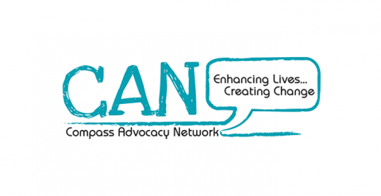](https://www.google.com/url?sa=i&rct=j&q=&esrc=s&source=images&cd=&ved=2ahUKEwiOtuCv5vneAhUCCxoKHcvGBiEQjRx6BAgBEAU&url=https://www.socialenterpriseni.org/showcase/compass-advocacy-network&psig=AOvVaw2DakYec28Q2omqtJd3cmua&ust=1543587685060746)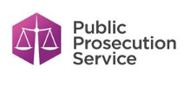[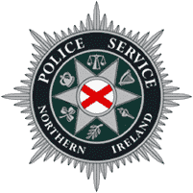](https://www.google.com/url?sa=i&rct=j&q=&esrc=s&source=images&cd=&cad=rja&uact=8&ved=2ahUKEwje1_ua5vneAhURCxoKHSzGDXsQjRx6BAgBEAU&url=https://en.wikipedia.org/wiki/Police_Service_of_Northern_Ireland&psig=AOvVaw1pksgZP2WmJMm2ws-yCxpw&ust=1543587632698644)

**The JustUS Card is for people with a learning disability or autism spectrum condition who need to speak to the police. You can use it to share important information about yourself and how you like to communicate.**