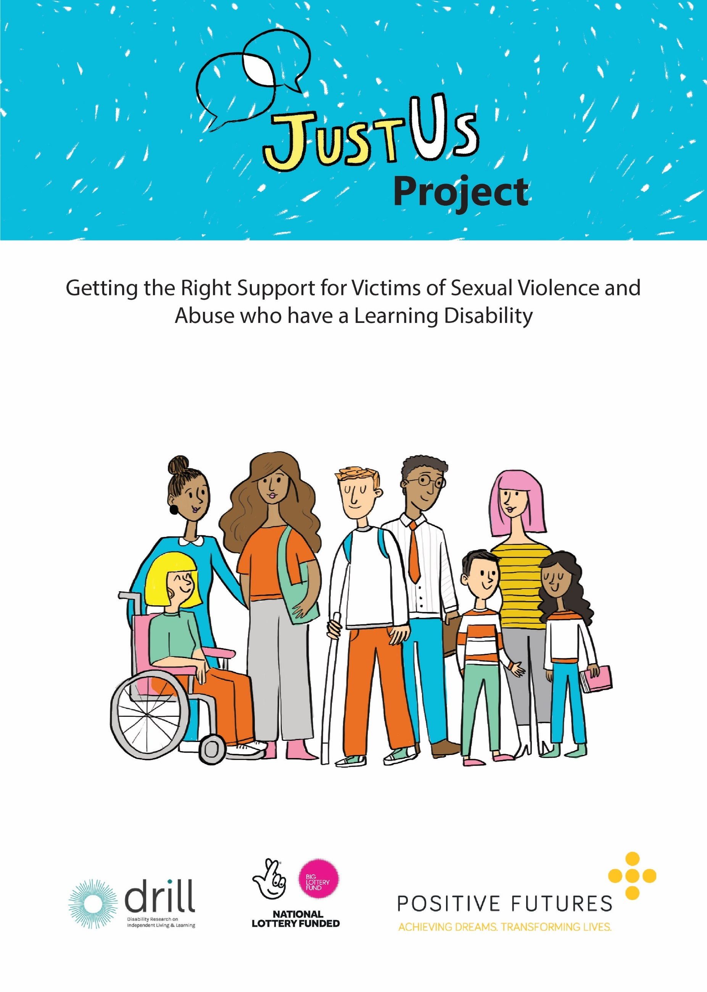
Project Summary

Overview
The JustUS Project is a partnership project led by Positive Futures and working with Compass Advocacy Network, Informing Choices NI (formerly FPA), Nexus NI, the Police Service of Northern Ireland (PSNI), the Public Prosecution Service (PPS) and Queen’s University Belfast (QUB). The project has been working to improve support for people with a learning disability who have experienced sexual violence and abuse.
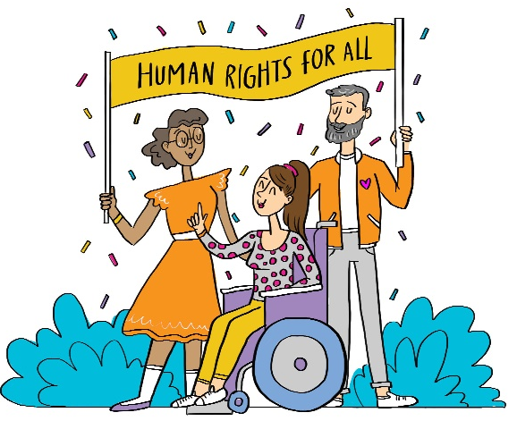
Project Advocates
The project is co-led by 4 people with a learning disability who act as Project Advocates and are involved in the leadership and delivery of the project.
“People with a disability have a voice that must be heard when working for their human rights. That is why I got involved in this project as an advocate!”
- Project Advocate
Project Outcomes
Pilot Counselling Programme
Following training on learning disability delivered by Positive Futures, Nexus NI created a counselling programme for 13 people with a learning disability. 10 of these people took part in an evaluation led by QUB. This meant that a researcher from QUB asked them questions about how the counselling was helping them. You can read the results of this in the QUB evaluation report.
PSNI & PPS Training
We delivered a training session for 20 people from the PSNI & PPS to support them to feel more confident when working with someone who has a learning disability. Everyone who took part in the training said they would recommend it!
“I deal with people as victims of crime, witnesses and defendants, and this training will help inform how I interact with them and support them to engage with the criminal justice process”
“There is a huge gap of need for this training across every work area in the PSNI”
- Training participants

Screening Tool
The JustUS Project has been working to create a screening tool to support first response officers (police officers who come out when a crime has happened) and call handlers (the people who answer phone calls to the police) to check if someone may have a learning disability. This will be tested this year.

Easy-Read Guide
We have made an illustrated easy-read guide that explains criminal justice processes (what happens at the police station and at court) for people with a learning disability. This is available in 4 languages. We have also made an animated video that tells people with a learning disability how to report sexual abuse and what support they can get.
JustUS Card
The JustUS Card has been created for people with a learning disability to share information with the PSNI and PPS on how they communicate best.
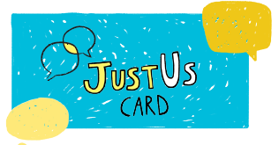 | - Unfold the card and fill in the information about yourself and how you communicate best.  - Fold the card back up and keep it in your pocket, purse or wallet (or somewhere else safe).  - If you need to speak to the police, you can show them the card to help them to communicate with you.

JustUS Website
To find out more about more about the JustUS Project, you can visit our website

www.Justusni.org

